AFE-like Hysteresis Loops for Doped HfO2 Field Induced Phase Change vs. Depolarization Fields

|  |  |  |
| --- | --- | --- |
| D. Spirito, S. Gorfman | T. Schenk  Luxembourg Institute of Science and Technology  Belvaux, Luxembourg | P. D. Lomenzo, T. Mikolajick, U. Schroeder  NaMLab gGmbH/TU Dresden Dresden, Germany  uwe.schroeder@namlab.com |
| Tel Aviv University Tel Aviv, Israel |

***Abstract*—Most**  **pristine**  **doped**  **HfO2**  **polarization-field hysteresis loops show a pinched hysteresis and discussions are ongoing to explain this AFE-like switching behavior. Main causes discussed in literature are related to a field induced phase change effects or linked to depolarization fields from non-polar phase regions in**  **ferroelectric**  **HfO2.**  **Structural**  **and**  **electrical characterization results are compared to distinguish between the different causes.**

***Keywords—Ferroelectric HfO2; AFE-like hysteresis, micro-spot XRD; depolarization field; wake-up cycling***

I. INTRODUCTION

Ferroelectricity in doped HfO2 gained a lot of interest after the first publication of results in 20111 since the ferroelectric films are highly scalable, lead free, and CMOS compatible, making the material very interesting for future semiconductor applications in non-volatile memory and logic applications. Ferroelectric doped HfO2 based capacitor structures are typically formed between two metal nitride or noble metal electrodes. Dopants in HfO2 can be selected from a wide range of dopants which are smaller (e.g. Si, Al, Ge) or larger (e.g. Y, Sr, La) than the Hf ion itself. In all cases, remanent polarization values of about 15 to 25 µC/cm2 with a coercive field of 1-2 MV/cm can be reached when the physical thickness of the layer is about 5-50 nm for most ALD, PVD, PLD, or CSD deposited layers2. For the PLD and CSD case, even higher thickness values up to 1 µm with good FE properties can be reached. Especially for higher doping concentrations of smaller dopants, like Si and Al or for Zr-rich Hf1-xZrxO2 films, an antiferroelectric (AFE)-like pinched hysteresis loop is observed. AFE-like behavior was attributed to a field induced transformation of a non-polar tetragonal to polar orthorhombic phase1,2,4. Within this abstract a detailed structural and electrical investigation is performed to gain a more detailed inside view on this AFE-like switching behavior.

II. METHODS/RESULTS

Capacitor stacks consisting of an ALD deposited Si doped HfO2 and mixed Hf1-xZrxO2 amorphous dielectrics positioned in between two PVD deposited TiN electrodes on a Si substrate are annealed to gain AFE-like properties in the doped HfO2 layer. Typical capacitor diameter is 100-200 µm. The basic film structure is determined by SEM, and GIXRD analysis. The basic polarization hysteresis characterization is performed on

an AixACCT TF Analyzer 3000. Since typical field cycling is performed in the kHz regime, a time resolved synchrotron based micro-spot XRD analysis is chosen to characterize possible field induced phase changes in the ferroelectric layer at the European Synchrotron Radiation Facility in Grenoble. The few 100 nm wide rectangular X-ray beam (λ = 0.018816 nm), concentrated through a 2-dimensional lens, enabled to characterize single contact pads during electric field cycling. The electrical field was applied using a function generator (Rohde & Schwarz HMF2550) triggered by the beamline software. The polarization was assessed via the transient currents determined from the voltage drop across a 50 Ω shunt resistor. This voltage drop was monitored via an oscilloscope (LeCroy WaveSurfer 44Xs).

III. DISCUSSION/INTERPRETATION

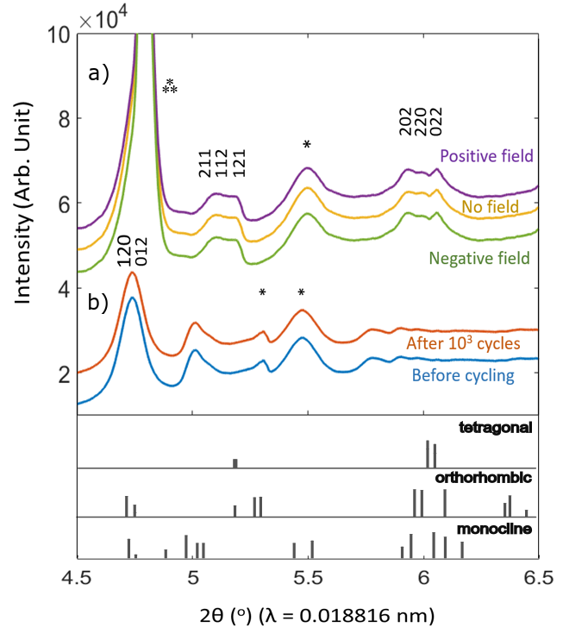

Fig. 1: Synchrotron based micro-spot XRD measurements on a 200um sized metal/ferroelectric/metal capacitor a) with and with applied field for a 5.6 cat% Si doped HfO2 sample and b) before and after 103 field cycles of an AFE like Hf0.3Zr0.7O2. Orthorhombic peaks are assigned, monoclinic peaks are marked (*). Tungsten needle contacting pad during the in-situ field cycling measurement (⁂).

Synchrotron based micro-spot XRD measurements are chosen to determine the macroscopic phase change in an AFE-

like sample when an external field is applied similar to a polarization hysteresis measurement. The clearly pinched hysteresis loop of a 5.6 cation % Si doped HfO2 film is shown in Fig. 2b. Micro-spot XRD on a 200 µm sized metal/ ferroelectric/metal capacitor stack revealed no significant change in the macroscopic XRD pattern indicating no large scale phase change when a positive or negative field of 3 MV/cm² is applied to the structure (Fig. 1a). Independent of the applied field, a polycrystalline structure with orthorhombic, tetragonal and minor monoclinic phase portions is present. Similar measurements with a transmission electron microscope (TEM) on a pure AFE-like ZrO2 sample indicated a predominately tetragonal phase structure which showed small structural changes on the microscopic scale when an external field of 4 MV/cm² is applied3. Overall, the structure seems to be stable when a field is applied, but minor changes in the local phase are possible.

Similar trends were detected for the field cycling case. Field cycling has been postulated to lead to structural changes in ferroelectric HfO2 which correspond to the macroscopically measured hysteresis characteristics5. Here, a Hf0.3Zr0.7O2 sample with strong wake-up effects during field cycling is chosen for micro-spot XRD characterization. Again, no change in the XRD pattern can be detected before and after field cycling (Fig. 1b). For a similar Gd doped HfO2 sample with strong wake-up during field cycling, Hoffmann et al. reported also no phase change during field cycling in micro-spot XRD4, but TEM again revealed structural changes on the microscopic scale5. Phase transformations of non-polar doped HfO2 regions to the polar orthorhombic phase were reported. Accordingly, discussions were ongoing to find new explanations for the occurrence of the AFE-like pinched hysteresis loop for doped HfO2 films and changes in the hysteresis loop during field cycling.

Calculations of the depolarization field caused by the finite screening length within TiN electrodes or by dead layer effects due to non-switching interface layers in between the ferroelectric layer and the metal electrode indicate a depolarization field >1 MV/cm² for 10 nm thick doped HfO2 films6. Non-polar phase regions in a ferroelectric doped HfO2 layer have been confirmed by TEM measurements5. Based on this depolarization field value, the impact on the hysteresis loop can be calculated. Assuming an increasing amount of the non-polar tetragonal phase within an orthorhombic film, this can result in an increased pinching of the hysteresis loop for 10 nm doped HfO2 films (Fig. 2a). Similar experimental hysteresis loops were reported for Si doped HfO2 (Fig. 2b)7, Al doped HfO28, and Hf1-xZrxO2 layer9.

The finite screening length/dead layer model can also be applied to explain a depinching of the hysteresis loop during field cycling. So far in literature, a combination of domain depinning10 and a charge movement based phase transition5,10 is discussed to explain a clear change in the hysteresis loop during field cycling. But, as discussed before, the initially pinched hysteresis loop could arise due to depolarization fields. A reduction of the depolarization field during field cycling could occur due to interfacial trapped screening charges which may not lead to any macroscopically observable structural

changes and is in general agreement with the previously mentioned structural measurements.

IV. CONCLUSIONS

Structural characterization measurements indicate that AFE-like hysteresis shapes are rather caused by depolarization fields related to non-polar regions in ferroelectric HfO2 than by large scale field induced phase changes. However, some phase changes can be seen in microscopic TEM measurements in local regions. Since the phase changes cannot be detected in macroscopic XRD measurements, the effects seem unlikely to occur at a large scale.

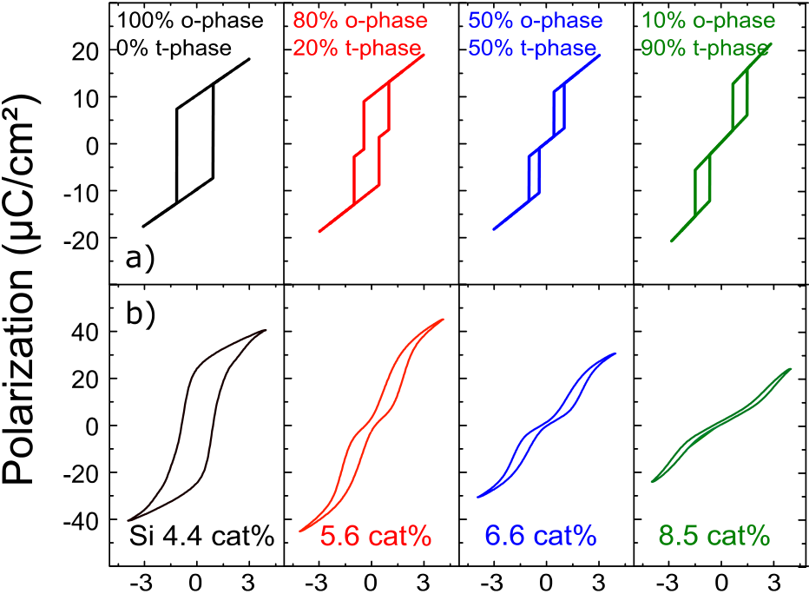



Fig. 2.: Polarization vs. applied electric field hysteresis loops for different non-polar tetragonal portions in a ferroelectric orthorhombic phase for a) modelled and b) experimental 10 nm Si doped HfO2 in a capacitor structure7.

ACKNOWLEDGMENT

The XRD experiments were performed on beamline ID31 at the European Synchrotron Radiation Facility (ESRF), Grenoble, France (proposal MA-4251). We are grateful to V. Honkimäki, F. Russello and I. Martens at the ESRF for providing assistance in using beamline ID31.

REFERENCES

[1]T.S. Boescke, J. Müller, D. Bräuhaus, U. Schroeder, and U. Böttger,

„Ferroelectricity in hafnium oxide thin films“, Appl. Phys. Lett 99, 102903 (2011)

[2]U. Schroeder, C.H. Hwang, H. Funakubo (Eds), „Ferroelectricity in Doped Hafnium Oxide“: Materials, Properties and Devices, Chapt. 3, Elsevier Woodhead Series, 2019

[3]S. Lombardo, C. Nelson, K. Chae, S. Reyes-Lillo, A. Khan et al., “Atomic-scale imaging of polarization switching in an (anti-) ferroelectric memory material: Zirconia”, VLSI 2020 submitted, Honolulu.

[4]M. Hoffmann, U. Schroeder, T. Schenk, T. Shimizu, H. Funakubo, O. Sakata, et al., and T. Mikolajick; ‚Stabilizing the Ferroelectric Phase in Doped Hafnium Oxide’, Journal of Applied Physics 118, 072006 (2015);

[5]E.D. Grimley, T. Schenk, X. Sang, M. Pešic´, U. Schroeder, T. Mikolajick, J. M. LeBeau, “Structural Changes Underlying Field-Cycling Phenomena in Ferroelectric HfO2 Thin Films,” Adv. Electron. Mater. 2016, 2, 1600173.

[6]P.D. Lomenzo, C. Richter,T. Mikolajick and U. Schroeder,“Depolarization induced antiferroelectricity and wake-up in ferroelectric hafnia”, Phys. Rev B, submitted

[7]E. Yurchuk, J. Müller, S. Knebel, J. Sundqvist, A.P. Graham, T. Melde,

U. Schroeder, T. Mikolajick, „Impact of layer thickness on the

ferroelectric behaviour of silicon doped hafnium oxide thin films“,Thin Solid Films 533 (2013) 88–92

[8]S. Mueller, J. Mueller, A. Singh, S. Riedel, J. Sundqvist, U. Schroeder, and T. Mikolajick, “Incipient Ferroelectricity in Al-Doped HfO2 Thin Films”, Adv. Funct. Mater. 2012, 22, 2412–2417.

[9]J. Mü ller, T. S. Bö scke, U. Schrö der, S. Mueller, D. Brä uhaus, U. Bö ttger, L. Frey, and T. Mikolajick, “Ferroelectricity in Simple Binary ZrO2 and HfO2,” Nano Lett. 2012, 12, 4318−4323.

[10]M. Pešic´, F.P.G. Fengler, L. Larcher, A. Padovani, T. Schenk, E.D. Grimley, X. Sang, J. M. LeBeau, S. Slesazeck, U. Schroeder, and T. Mikolajick, “Physical Mechanisms behind the Field-Cycling Behavior of HfO2 Based Ferroelectric Capacitors,” Adv. Funct. Mater. 2016, 26, 4601–4612.